

**Department of Aviation**

**Flight Lab Completion Repor**t

Dear MNSU Aviation Student,

Congratulations on passing your stage check and completing your flight lab. In order to receive a flight lab grade, please fill out this form and send it to Professor Jeff Peterson ([jeffrey.peterson-2@mnsu.edu](mailto:jeffrey.peterson-2@mnsu.edu)) and Professor Cody Howe ([cody.howe.2@mnsu.edu](mailto:cody.howe@mnsu.edu)). Your grade will be applied per the Flight Lab Grading Rubric found below and in your Aviation Student Handbook. Completion dates and exam scores will be verified in Talon.

Name: ______________________________

Tech ID: ______________

Flight Lab Completed (Example - AVIA 153): ____________

Semester Enrolled (Example - Fall 2023 mid-semester): ____________

Date of first lesson completion: ____________

Date of Stage Check completion: ____________

FAA Written Exam score on the first attempt (n/a for AVIA 151, 241, 251, and 364): ___________

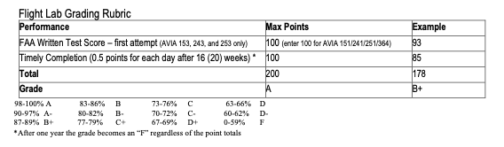

Flight Lab Grading Rubric, copied/pasted from the Aviation Student Handbook